**Lab 1**

**Brief Introduction of COAL and Software Installation**

Computer Organization refers to the way in which the hardware components of a computer system are arranged and interconnected. Computer Organization and Assembly Language (COAL) Programming deals with lower-level computer programming—machine or assembly language, and how these are used in the typical computer system. Assembly language programming develops a very basic and low-level understanding of the computer. In higher level languages there is a distance between the computer and the programmer. This is because higher level languages are designed to be closer and friendlier to the programmer, thereby creating distance with the machine. This distance is covered by translators which are called compilers and interpreters. The aim of programming in assembly language is to bypass these intermediates and talk directly with the computer.

Different architectures of the computer system are adopted to understand the rules, methods, and procedures that describe the execution and functionality of the entire computer system. John von Neumann coined and developed an architecture named **von Neumann architecture** . The computer we are using nowadays is based on the von Neumann architecture. It has some concepts. It is also known as Princeton architecture. It renders a unique design for the electronic digital systems having the following components:

* A Central Processing Unit (CPU) with arithmetic and logic unit (ALU) and processors with attached registers.
* A memory that can store data and instructions.
* External mass storage or secondary storage.
* A Control Unit (CU) with the ability to hold instructions in the program counter (PC) or instruction register (IR).
* Input and output mechanisms and peripherals.

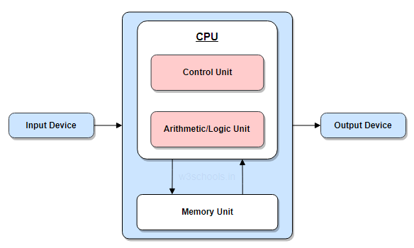

Figure 1: Von Neumann Architecture

The von Neumann design thus constitutes the foundation of modern computing. The Harvard architecture, a similar model, had committed data addresses and buses for reading and writing to memory. It won because von Neumann's architecture was easier to execute in real hardware.

**Software Required**

* DOSBox (An Emulator)
* Notepad ++/Visual Studio Code for Assembly Coding

**Objective of Using DOSBox**

DOSBox is an emulator and the purpose of using it here is to study a specific 16-bit architecture of Intel IBM PC using assembly language on a 32-bit or 64-bit machine.

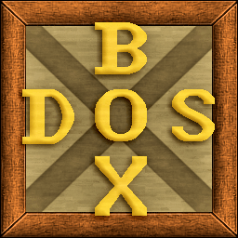

Figure 2: DOSBox Icon

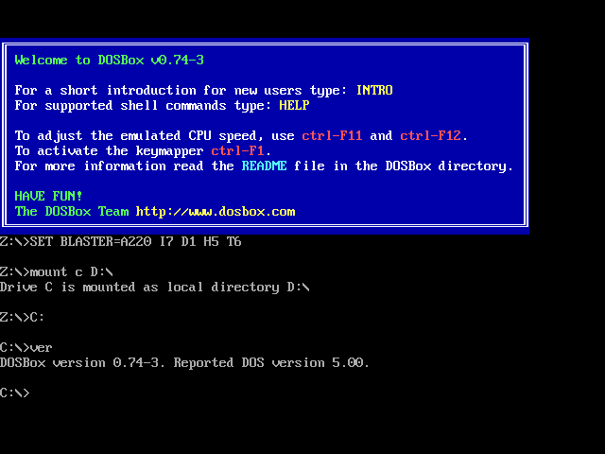

Figure 3: Interface of the DOSBox

**Steps of Installation for Windows**

Follow these steps if you have a Windows PC to download and install DOSBox:

* Open a browser and go to the [DOSBox download page](https://www.dosbox.com/download.php?main=1).
* Locate the latest Windows installer download and select it.
* After the download is completed, run the installer.
* Follow the on-screen directions. It's fairly simple, and the default options should suffice in most situations.

**Lab Work**

* Installation of the Softwares
* Getting familiar with the interface of DOSBox and making **.asm** files in NotePad++

-Screenshot of the DOSBox with commands done in the lab (Lab 1: mounting drive, compilation of assembly file, creating output file for afd and displaying it in afd)

- Screenshot of the .asm file created in Notepad++ or Visual Studio Code.